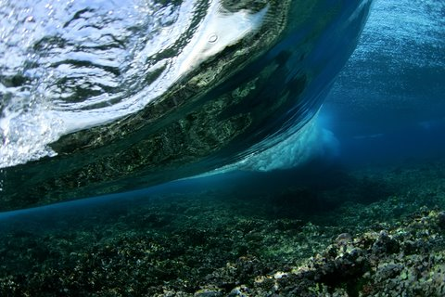Earth is composed of 71% water and 29% land. It is estimated that the oceans contain 312 million trillion gallons of saltwater that cannot be consumed as drinking water by humans. Then, why not use this abundant natural resource as an effective means of renewable energy source?

*Figure 1. The Ocean*

*Source: Underwater Wave Stock Photos*

Hydroelectric energy, wave, energy, and tidal energy are three such types of renewable energy forms derived from water. However lucrative or sought after, the hydroelectric power presents a big challenge. Practical implementation of hydroelectric harness requires constructing a water holding body such as a dam near a river or lake. Unfortunately, these rivers and lakes make up only 4.2% (mostly fresh water) of all the water on Earth. Tidal and wave – the other two renewable energy forms – utilize the remaining 95.8% of water, which is the saltwater found in oceans.

Tidal energy is harnessed via the tides in the ocean. Oceanic tides have high kinetic and potential energy – enough to increase Earth’s rotation around its own axis. The mechanical energy contained in these tides has been increasing, causing a significant loss in Earth’s rotational energy. In 620 million years, Earth has lost 17% of its rotational energy causing the days to grow longer from 22 hours to now 24 hours. Since tides are a result of Earth’s rotation around its axes and the proximity to the moon, it is quiet an inexhaustible phenomenon. Conversely, as long as the Earth rotates around itself, the moon around earth, the tides in earth’s oceans remain strong and therefore forming a renewable source of energy.

There are four common constructs that harness tidal energy – tidal barrage, tidal lagoon, dynamic tidal power plant, and tidal stream generator.

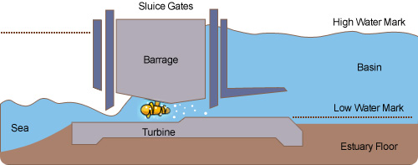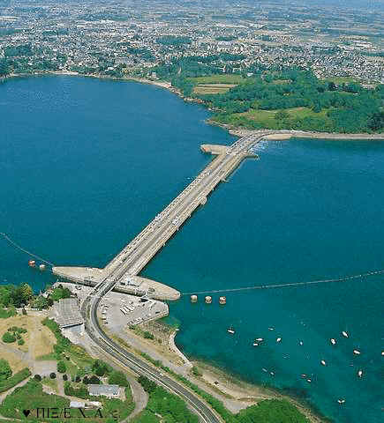 Tidal barrage and lagoons use well-placed dams and potential energy difference between high and low tides to generate electricity. The potential energy of a tide is harnessed by channeling water from a water source into a big reservoir that is placed on high ground. Once released, it passes through a dam containing turbines, and falls on to a surface lower than the reservoir. The turbines then convert the tidal energy into a mechanical energy, then forming electricity through the use of generators. This is the same concept as a hydroelectric plant, just on a smaller scale.

*Figure 2.1. Rance tidal barrage, Northwest France. This is the largest in the world.*

*Source: Tidal Energy (Tidal Power)."*

*Figure 2.2. Tidal barrage flow diagram.*

*Source: Energyland: Tidal Energy*

Bays and estuaries are the two common locations for tidal barrages and lagoons. These locations come with some challenges of their own. Having a barrage in a bay might decrease saltwater, which leads to death of sea fish. This results in a change in the overall ecosystem that becomes unsuitable for fish. In addition, migrating fish might try to pass through the turbines, which results in unintended death and therefore decrease in overall numbers of fish in the region. Overseeing these disadvantages, there are valuable advantages of tidal barrages in these locations. Tidal barrage constructs result in calming the waves and allowing access to neighboring lands through bridges. At the same time, the overall production of electricity from a non-crude material like tides means clean and minimal pollution in the process.

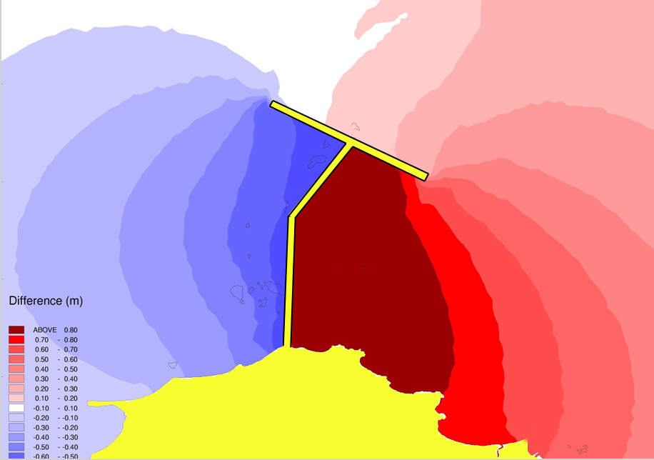Dynamic tidal power (DTP) plant may be seen as the most efficient method for harnessing tidal energy. It is important to note that the mechanics behind DTP are currently a theory as a proposed idea. It consists of harnessing the interaction between potential and kinetic energy in a coast or ocean. The proposed idea is to construct long dams with the length of around 40km perpendicular to the coast and into the ocean (see diagram on the right). This involves combining the kinetic energy of the tide as it passes through the turbines dam as well as the potential energy from a higher side to the lower side of the dam; as show in the diagram above, the higher level of water is displayed in red and the lower level of water is displayed in blue. Since the tides flow only one direction, such as during the day the tides flow in one direction and during the night they flow in the opposite direction. Hence, in order to acquire maximum efficiency and possibly preventing the destruction of normal turbines during the night, as the kinetic energy of a tide is strong enough to destroy the entire dam without a flow, bi-directional turbines are to be installed in such a dam. These turbines flow in both directions, converting the kinetic energy into electricity. In order to harness potential energy, there isn’t something special to be done. The construction alone contains a side effect, due to the long dam of around 40km in length; it disrupts, or influences, the horizontal tidal movement allowing two sides of the dam with different water levels creating potential energy. Even though it is theoretical, the DTP plant can generate approximately 30TWh, annually. There is a linear relationship between the length of the dam and the power generated, the longer the dam the more power generated by it. An average person consumes around 6800kWh annually, resulting that the DTP plant can supply energy, on average, to 4 million people. The potential for such a project is very high as there are numerous locations where such a DTP plant can be constructed. However after the proposal of the DTP plant in 1997 (made by Kees Hulsbergen and Rob Steijn, Dutch engineers), the project has never been executed due to the raw tidal energy itself. Theoretically we contain the technology to construct a DTP plant, however, the energy contained by Earth’s tides is unpredictable. The most likely flaw in this project is the sheer force of the tides destroying the 40km long dam due to unpredictable gravitational occurrences between the moon and sun, and earth’s rotation. Nevertheless, this project can be the key to harnessing an enormous amount of tidal energy.

*Figure 3. Diagram for a DTP plant.*

*Source:* *Power Programme.*

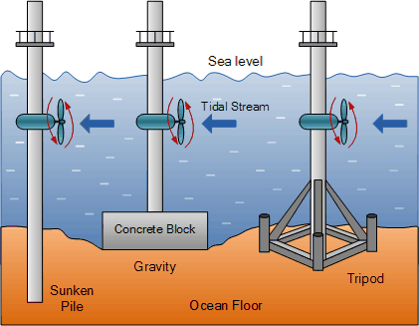Tidal stream generator or Tidal energy converter (TEC) is a method of acquiring energy similar to wind energy. Instead of having wind turbines in the air, they are held under water to allow the flow and water current/tides to spin the turbines to generate tidal energy (as shown on the left). In addition, this method is the least expensive and is the most common method used to harness tidal energy. Due to the fact that water density is approx. 800 times more than that of wind, the power generated by a TEC is far greater than that of wind turbines. However due to the weight of the turbines (more weight, more strength of the turbine), the water speed must be at least 2 knots, or 1 m/s, in order for the TEC to create energy. If the water speed is around 4 or 6 knots, then the TEC can generate up to 4 times the energy generated by wind turbines. Even though this happens to be a low cost generator of tidal energy, the turbines eventually start to bend due to the sheer force of the ocean/water currents, as a turbine can only harness up to 25% of the tidal energy. In order to determine the amount of power a turbine can construct, a formula was derived as shown:

*Figure 4.1. TEC underwater turbine flow diagram.*

*Source:* *Alternative Energy: Tidal Energy* Diagram

*Where*

*Cp: Turbine power coefficient*

*P: Power generated (watts)*

*: The density of water (1027kg/m3)*

*A: The sweep area of the turbine (m2)*

*V: Velocity of the flow.*

As explained above, each and every one of these methods of generating tidal energy contains a disadvantage and advantage. Due to the disadvantages, the harnessing of tidal energy is still in its prototype years. Some reasons are that it requires tremendous amounts of investments upfront, such as for the DTP plant. Generating power is not an issue, by now it is common knowledge that the ocean can generate tremendous amount of energy, however, storing it still requires research. In addition it could potentially harm the marine animals and their migration to the ocean, such as with the Tidal barrages in areas like bays. All these disadvantages lead to the fact that in current day, there are only prototypes that harness tidal energy; there hasn’t been a large-scale production yet.

Tidal energy isn’t the only renewable energy that uses the 95.8% of Earth’s salt water; there is one other, wave energy. Often there is confusion between wave energy and tidal energy as if they were the same time with different names, however they are completely different from each other. Wave energy relies on the strength of the waves that are generated by the height of the wave, generated by the wind speed above the ocean surface. Waves travel all around the globe and the stronger and longer the wind blows on top of the sea, the stronger and faster the waves would travel the ocean with very little energy loss. The most positive attraction of wave energy, that it is accessible everywhere around the globe.

In comparison to tidal energy, wave energy also consists of a linear relationship between the energy generated and the height of the wave. The energy of the wave is proportional to the square of the wave’s height. For example, if there is a two-meter high wave, it will have 4x the energy of a one-meter wave. In order to predict the power generated by each wave, a formula has been derived:

*Where:*

*P: The wave energy flux per unit of wave crest length*

*Hm0: The significant wave height*

*Te: The energy period*

*: The water density (1027 kg/m3)*

*g: The acceleration by gravity (9.8 m/s2)*

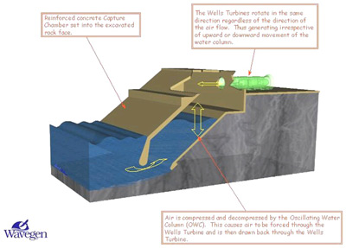There are two common ways to harness wave energy. One of them is called the Oscillating Water Column (OWC), which is normally placed on a coast. This method is classified as a terminator, wave energy devices that are oriented perpendicular to the direction of the wave. The very first prototype was placed on a coast over in Scotland. It has two openings, one for water to come up the column as shown in the diagram and the other to pull air into the column and out. It uses a turbine that is powered by air being pressurized in the column and spinning the turbine by the wave. This method allows even the smallest of waves to generate energy. As soon as the wave hits this column, the water level rises in the column, pushing the air through the turbine and then dispensing the air through the back.

*Figure 5.1. The OWC diagram. Currently a prototype in Scotland.*

*Source:* *How Wave Energy Works*

There is another common kind of WEC (wave every converter device) method that can be viewed as a point absorber or an aquabuoy. The main purpose of these devices is to absorb the energy of the wave. It is constructed as a vertical tube, that floats on the coast, built in a way that the waves rush in and drives the buoyant disk connected to hose pumps, which then pressurizes the sea water inside. Then the pressurized water drives the built in turbine, converting it into electrical energy that is then transferred underneath the ocean surface to a central point. The only issue with aquabuoy is that it is quite expensive to produce, and they are spread in a wide area of the coast allowing no commercial use or no sail zone.

*Figure 5.2. .Aquabuoy specifications diagram*

*Source: Alt Energy: Wave Power*

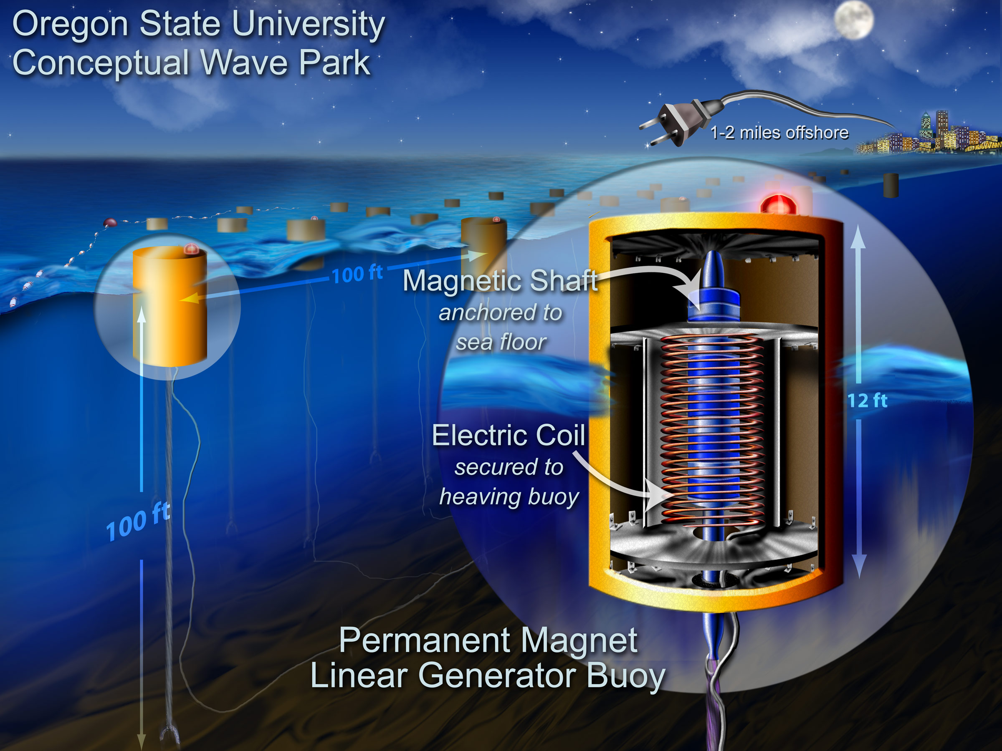 There are many disadvantages with Wave energy in today’s world, as it is very expensive to generate WECs and they aren’t as efficient. The aquabuoy can only harness up to 10% of the total wave’s energy. Theoretically, if the wave’s energy is fully exploited, then it would be enough energy to supply 40% of the entire world’s population. However, more research as to be done in order to create more economical and efficient WECs in order to harness majority of the wave’s energy.

Tidal energy and wave energy are the two types of inexhaustible and renewable energy that rely only on the 312 million trillion gallons of water on earth. They contain a lot of potential, but very little investment that results into less efficient technology. These two energies are completely green and emission-free. No harm could be done to the environment through the generation of these two energies.

Work Cited

"Energy Resources: Tidal Power." *Energy Resources: Tidal Power*. N.p., n.d. Web. 20

June 2014. <http://www.darvill.clara.net/altenerg/tidal.htm>.

"Marine Current Turbines." *Tidal Energy*. N.p., n.d. Web. 21 June 2014.

<http://www.marineturbines.com/Tidal-Energy>.

McGrath, Jane. "How Wave Energy Works." *HowStuffWorks*. HowStuffWorks.com, 15

July 2008. Web. 21 June 2014.

<http://science.howstuffworks.com/environmental/earth/oceanography/w

ave-energy3.htm>.

"Renewable Energy." *Forms of Renewable Energy*. N.p., n.d. Web. 21 June 2014.

<http://www.altenergy.org/renewables/renewables.html>.

"Tidal Energy." *- National Geographic Education*. National Geographic, n.d. Web. 21

June 2014.

<http://education.nationalgeographic.com/education/encyclopedia/tidal-

energy/?ar_a=1>.

"Tidal Power." *ESRU*. N.p., n.d. Web. 21 June 2014.

<http://www.esru.strath.ac.uk/EandE/Web_sites/0102/RE_info/Tidal%20P

ower.htm>.

"Wave Power." *ESRU*. N.p., n.d. Web. 21June 2014.

<http://www.esru.strath.ac.uk/EandE/Web_sites/0102/RE_info/wave%20p

ower.htm>.

"Wave Power." *Pelamis*. N.p., n.d. Web. 21 June 2014.

<http://www.pelamiswave.com/wave-power>.

"Alternative Energy: Tidal Energy Diagram." *Alternative Energy Tutorials*. N.p., n.d.

Web. 22 June 2014. http://www.alternative-energy-t utorials.com/images/stories/tidal/alt93.gif>.

"Power Programme." *DTP*. N.p., n.d. Web. 21 June 2014.

<http://www.powerdtp.nl/DTP/default.aspx>.

*"Energyland: Tidal Energy." Energyland. N.p., n.d. Web.* 22 June 2014.

*<http://www.energyland.emsd.gov.hk/en/energy/renewable/tidal.html>.*

*"Tidal Energy (Tidal Power)." Renewable Green Energy Power RSS. N.p.,*

*n.d. Web.* 22 June 2014. *<http://www.renewablegreenenergypower.com/tidal-energy-tidal-power-facts-for-kids/>.*

*"Underwater Wave Stock Photos." Underwater Wave Stock Photos – 8,646 Underwater*

*Wave Stock Images, Stock Photography & Pictures. N.p., n.d. Web.* 22 June 2014.*<http://www.dreamstime.com/photos-images/underwater-wave.html>.*

*"Alt Energy: Wave Power." - Energy from Ocean Surface Waves. N.p., n.d. Web.* 22 June

2014. *<http://www.alternative-energy-news.info/technology/hydro/wave-*

*power/>.*